# AwesomeEnterpriseApp Project Proposal/Introduction

## Overview

The AwesomeEnterpriseApp project is an application for tourists in New York City. It is specifically aimed at tourists interested in film history. It is designed to help the tourist to find a restaurant near the filming location of their chosen film. The user will be able to select a film location and will be presented with a list of restaurants that fall within a user-specified radius of the location. These restaurants will be presented with location, contact details and business hours.

The restaurants that are presented to the user will be entities that are registered with the application. The restaurant owner is required to make an account with which they can create or edit a restaurant entity. This creates business potential for both the restaurant and the application. The restaurants are part of a select list associated with the film locations, and for the application they generate advertising revenue.

The application is designed with New York City film locations in mind, but will be expandable to other cities upon presentation of an API meeting the criteria of the New York Open City API.

## Proposed Functionality

The AwesomeEnterpriseApp project shall perform the following functionality:

* For the restaurant owner:
  + Present the user with a joint login/registration form (see fig.1)
  + This will create a user account within the application
  + Name, email and password will be entered into the database
  + The password will be encrypted
  + Upon registration the user is presented with a restaurant details form (see fig.2)
  + This collects details such as name, cuisine type, contact details and address
  + This information is sent to the application where the map coordinates of the address are determined using the Google Maps API
  + These details along with the extracted map coordinates are saved to the database
  + Upon login the user is presented with the same form populated with the details of their registered restaurant
* For the end-user:
  + Present the user with a form with a drop-down menu populated with a list of film titles (see fig.3)
  + These titles are aggregated from the New York Open City API.
  + Upon selection of a film title, the second drop-down menu is populated with a list of locations in New York where filming has taken place for the selected choice, coming from the same API
  + The user also selects a range (radius) within which to search
  + This information is sent to the application
  + The application pulls the restaurant coordinates from the database and an algorithm is used to determine a list of entries whose coordinates lie within the selected radius of the selected film location coordinates
  + The details of these restaurants are then pulled from the database and returned to the user form presenting a list of details of restaurants within the selected parameters

## Initial Data Structure

* User Object
  + Name (varchar55)
  + Email (varchar55)
  + Password (varchar55)
  + Restaurant (Restaurant)
* Restaurant Object
  + Name (varchar55)
  + Tel (varchar55)
  + Cuisine (integer) (will be mapped to a static array of String-int constants)
  + Fanciness (integer) (will be mapped to a static array of String-int constants)
  + URL (varchar55)
  + Address (varchar255)
  + latCoord (float)
  + lngCoord (float)
  + CreationDate (DateTime)
  + ModificationDate (DateTime)
  + InactiveDate (DateTime)
  + Active (Boolean)

## Initial UI Prototypes

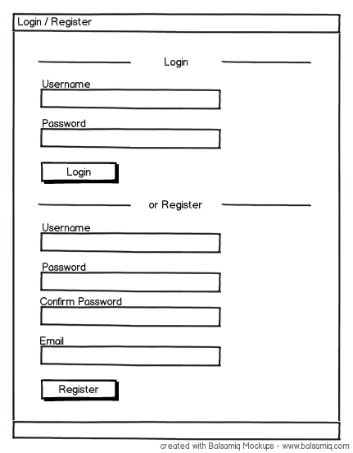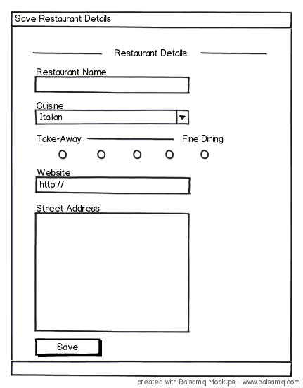

Fig.1 Fig.2

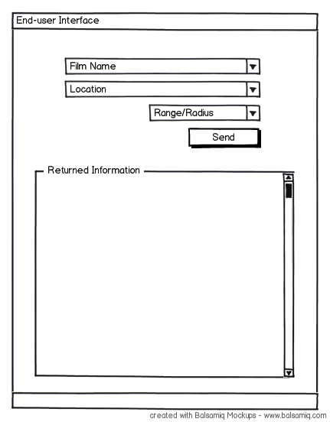

Fig. 3